Welcome to Bangkok, Gem Capital of the World!

Thailand – Land of Smiles! Anyone who has been to Thailand marvels at the friendliness and the hospitality of the Thai people. Unfortunately, while the majority of the smiles are genuine, a small minority of cheats and cons mars the image of Thailand through their indiscriminate deceit and trickery. Whether it is the lure of a good bargain or the potential to make some profit – many tourists unwittingly get caught in Thailand 's infamous gem scams.
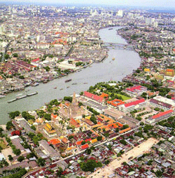
There are countless stories abound. Here are some variations:

• Friendly tuk-tuk driver offers you a free ride to your destination or a cheap ride at next to nothing. The condition is that you stop at a few shops “on the way”.

• Well-dressed passersby chat you up at popular tourist spots. They appear educated, seem sincere and well meaning. (They may claim to be a doctor, lawyer, university lecturer.. Eventually, they will let you in on a “secret” – a government organized gem and jewelry sale. They are so kind, they will even hail a taxi or tuk-tuk for you.

• You get into a taxi parked conveniently outside a hotel or on the main road. Taxi driver speaks good English and is very friendly. He chats you up and mentions that he just dropped off a passenger who left something in the backseat. Opening it up, it turns out to be gemstones. Since there is no way to reach the last passenger, he offers to sell it to you. He doesn't know their value so he asks you to give him a price that is reasonable.

• At a jewelry shop, the sales person assures you that the price you are getting for the jewelry she has shown you is guaranteed to make you at least 100% profit when you go back to your home country. The shop will even issue you “certificates”.

Having lived in Bangkok for a good 8 years now, I've heard many more variations – too many to recall and to describe. The one thing common to all, is the end result: Tourists pay exorbitant prices for poor quality gems and jewelry, or worse – for synthetic stones and fake gold worth practically nothing.

My advice to those who are approached is simple:

• Politely turn them down. There is no need to be hostile or antagonistic. You neither want to offend a genuinely friendly local seeking to practise his English, nor risk being assaulted by the people involved in this kind of scam.

• Always insist on metered fare. Don't accept any free rides from tuk-tuks or taxis.

• When in a taxi or tuk-tuk, don't be coerced into going to any shop you did not plan on visiting. If the driver persists, tell him to let you alight immediately. If he refuses, tell him you will call the tourist police (Dial: 1155 English. German & French spoken).

• Patronize only shops that are well established and/or members of the Thai Gem and Jewelry Association, Gem & Gold Association, Jewel Fest Club and other watchdog bodies.

• Gemstones are a good bargain in Thailand. However, be realistic. If you have no formal training in gemology, or lack gem buying experience, you risk purchasing synthetics, imitations, poor quality stones and/or stones that are treated but not disclosed to you.

• Buy because you like the gemstone or jewelry – not for the promise of profit. Unless you are dealing in wholesale quantities, you will still pay retail prices. Although you will still save money, you must not expect to make a huge profit from re-selling what you have bought.

• Go with your gut. If it doesn't feel right - WALK AWAY!

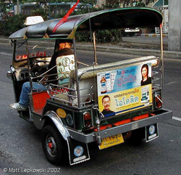
Hope this information helps those of you who may be thinking of visiting Thailand and buying gemstones. The stories may sound nightmarish, but frankly, if you just keep your head on your shoulders and you'll be fine! Have fun!

Yours Truly
Leach

